# Loss Calculations

We know that Vinmin: 220 V, Vinmax: 400 V, Vout: 12 V, Pout 100 W from project description. Also, switching frequency is around 100kHz in both input voltage cases. This is known from both detailed simulations and controller features. Moreover, transformer will produce magnetic and copper losses, therefore transformer efficiency ratio will be taken as 0.9 in calculations. Output diode STPS30170DJF-TR has around 1 V forward voltage in secondary current ratings. Primary and secondary side power calculations are made as follows.

|  |  |
| --- | --- |
|  |  |
|  |  |
|  |  |
|  |  |

Primary side switch power loss should be calculated to reach input power. Primary and secondary peak currents should be calculated to calculate switch power loss, therefore input power will be assumed as 125 W and analytical calculations will be compared with simulation results. Also, transformer turns ratio is decided as 4.33 in magnetic design.

|  |  |
| --- | --- |
|  |  |
|  |  |

Primary and secondary currents have triangular shape.

|  |  |
| --- | --- |
|  |  |
|  |  |
|  |  |
|  |  |

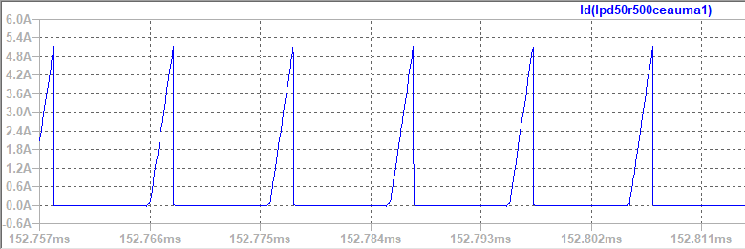

Figure MOSFET Current Waveform (Vin=220 V)

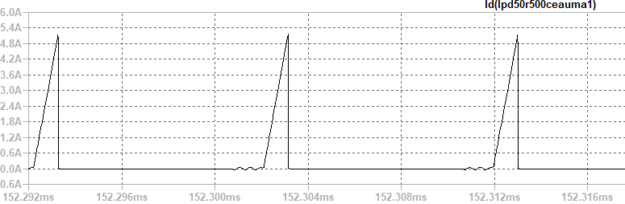

Figure MOSFET Current Waveform (Vin= 400 V)

Input current rms value is used in power loss calculation of MOSFET. It is calculated in LTspice as in figure **X.**

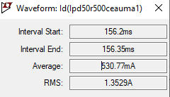

Figure Maximum value of MOSFET current

Since converter works in discontinuous conduction mode, we need dweel time to calculate secondary side peak current. Dwell time is estimated from simulations as 0.05*D*Ts.

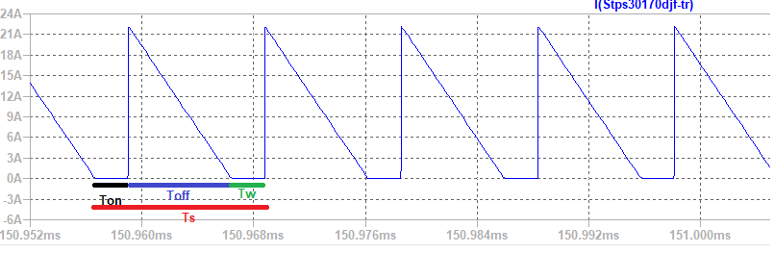

Figure Secondary Side Diode Current

|  |  |
| --- | --- |
|  |  |

Secondary side diode current value will be used in diode power loss, and it is calculated in LTspice.

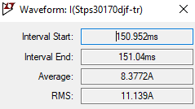

Figure Maximum value of diode current

Voltage drop on MOSFET is calculated as follows.

|  |  |
| --- | --- |
|  |  |

Power Calculation Table

|  |  |  |
| --- | --- | --- |
| Loss mechanism | Component | Model |
| Conduction | MOSFET |  |
| Switching | MOSFET |  |
| Switching – Output capacitance | MOSFET |  |
| Switching – Gate charge | MOSFET |  |
| Switching | MOSFET Diode |  |
| Conduction | Diode |  |
| Conduction – Copper loss | Transformer |  |
| Magnetic Loss | Transformer |  |
| Conduction | Shunt resistor |  |

MOSFET Datasheet <https://www.infineon.com/dgdl?fileId=db3a3043382e83730138514ff7881004>

Diode Datasheet <https://www.st.com/content/ccc/resource/technical/document/datasheet/25/7a/ac/5d/11/a8/48/3a/CD00255367.pdf/files/CD00255367.pdf/jcr:content/translations/en.CD00255367.pdf>

Maximum RDS value is 0.5 Ω in MOSFET Datasheet, therefore the worst case is calculated in MOSFET conduction loss. time is 19ns in the worst case, therefore the worst case is calculated in MOSFET switching losses. Typical , it is taken in calculation of output capacitance power loss. Maximum Gate threshold voltage of the MOSFET is 3.5V. Total Gate charge of the MOSDET is 18.7nC. Also, body diode of the MOSFET is taken into consideration while making calculation and its related values are taken from datasheet. Output diode has 0.85 V on voltage while it is conducting 8.33A. Also, output diode has not reverse recovery loss since it a Schottky diode. Magnetic loss parameters are taken from Magnetics website.